WEST YORKSHIRE FIRE & RESCUE SERVICE

JOB DESCRIPTION

POST TITLE: | Workshop Chargehand
GRADE: | Grade 7 + 4% management allowance + Standby Allowance
RESPONSIBLE TO: | Workshop Manager
PURPOSE OF POST: | To assist the workshop manager in scheduling work, and delivering and efficient, cost-effective facility for the service and repair of all vehicles and equipment.
ORGANISATIONAL CHART

MAIN DUTIES AND RESPONSIBILITIES OF THE ROLE

1.To supervise and monitor work carried out by Automotive Technicians at workshops and other sites as required, including roadside repair.

2. To carry out the full range of tasks of an Automotive Technician.

3. To ensure that workshop staff keep all records of job times correctly and to monitor job progress.

4. To ensure that all paperwork systems are adhered too, and to monitor stores requirements and progress.

5. Work from written and verbal instructions as necessary with minimal supervision.

6.To participate in the transport standby system in a supervisory capacity.

7.To assist the workshop manager to identify all training needs, including those of work experience students, and apprentices.

8.To assist department managers in implementing the Authority’s health & safety policy, and ensure compliance with all applicable regulations.

9. To assist the workshop manager with the security of the workshop complex and associated equipment, tools, etc.

10. To offer assistance, training and supervision to apprentices and work placements.

11. Undertake any other duties commensurate with the grade of the post as directed by line managers.

12. To ensure that core values are adhered to within the workshops.

13. To Progress and implement the Authority’s Equal Opportunities Policy.

ORGANISATIONAL WIDE RESPONSIBILITIES:

- Adherence to the Core Code which sets out five ethical principles, based on the Seven Principles of Public Life and West Yorkshire Fire Service Values.
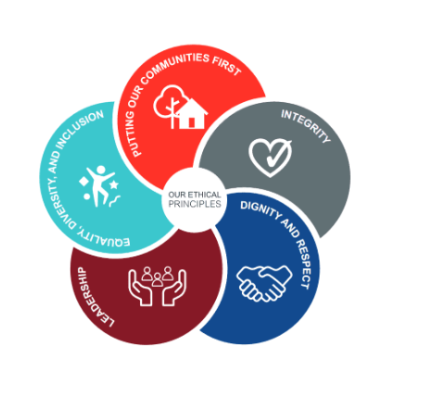

- To Implement and promote the Authority’s:
- Health and Safety policies.
- Equality and Diversity policies.
- Information Security Management System policies.
- Safeguarding policies.
- Business continuity policy and contingency arrangements.
- Policies related to General Data Protection Regulation and Data Protection Act 2018.
- Commitment to maintaining our Customer Service expectations.

- A satisfactory Standard Disclosure and Barring check is required for the role.

SKILLS AND EXPERIENCE REQUIREMENTS FOR THIS ROLE.

In the supporting statement section of the application form give clear, concise examples of how you meet all of the Essential person specification criteria (i.e. items you must be able to do from day one to be able to do the job), identified as ‘Application’ in order to be shortlisted for this vacancy. If a large number of applications are received, only those who also meet the Desirable criteria, identified as ‘Application’, will be shortlisted, i.e. criteria you need to do the job, but which could be learnt during training.

Please list or number the competency criteria below against which you are providing evidence/examples in order to structure your supporting statement in a well organized way.

There may be some criteria that are identified through ‘Selection Process’ only. You will only be assessed on these criteria during the selection process and not from your application form, this may involve tests, presentations, interview etc.

 | Experience. | Essential/ Desirable. | Where identified.
 | Considerable experience in the repair and maintenance of motor vehicles to include mechanical, electrical and bodywork repairs. | Essential | Application  & Selection Process
 | Knowledge of Volvo HGV vehicles. | Desirable | Application
 | To hold and maintain a current full valid car driving license. | Essential | Application
 | Must be enthusiastic and capable of leading a team, demonstrating leadership and motivational skills | Essential | Selection Process
 | To manage the workload through the workshop in an efficient manner | Essential | Selection Process

 | Education and Training. | Essential/ Desirable | Where identified.
 | Possession of a recognized apprenticeship in vehicle maintenance with City and Guilds Parts 1,2 and 3 Craft Studies or equivalent relevant qualification. | Essential | Application form
 | Must have a sound educational background and be literate and numerate or able to demonstrate an equivalent level of learning gained through life experience. | Essential | Application form
 | Must hold a qualification in supervision / management or working towards. | Desirable | Application form
 | To hold an IOSH certificate in health and safety. | Desirable | Application form

 | Special Knowledge and Skills. | Essential/ Desirable. | Where identified.
 | Possession of a LGV C or C + E Driving Licence | Desirable | Application
 | Knowledge of Health and Safety at Work Regulations within the workshop environment. | Essential | Selection Process
 | Be physically fit to carry out the full range of duties in a commercial workshop. The role requires lengthy periods of high physical exertion in confined spaces to assemble large mechanical components | Essential | Selection Process
 | Possession of a high level of physical co-ordination and skill to carry out duties listed at section 3, with associated use of machinery for manufacture and fabrication requiring a high degree of manual dexterity | Essential | Selection Process
 | Be able to maintain high levels of mental concentration for lengthy periods e.g. diagnostics of complex CAN and multiplex electrical systems. | Essential | Selection Process
 | Demonstrate an understanding of the importance of equality and diversity to WYFRS as an employer and service provider | Essential | Selection Process

Job Description: Last updated: 19/02/2024

